IPA -How to determine how many Process Flows Can Simultaneously Process
Step 1 – Launch Grid Management UI
Step 2 – Click the LPA Grid Node (Could be called LPA, LmrkDeferred, or LmrkFull)
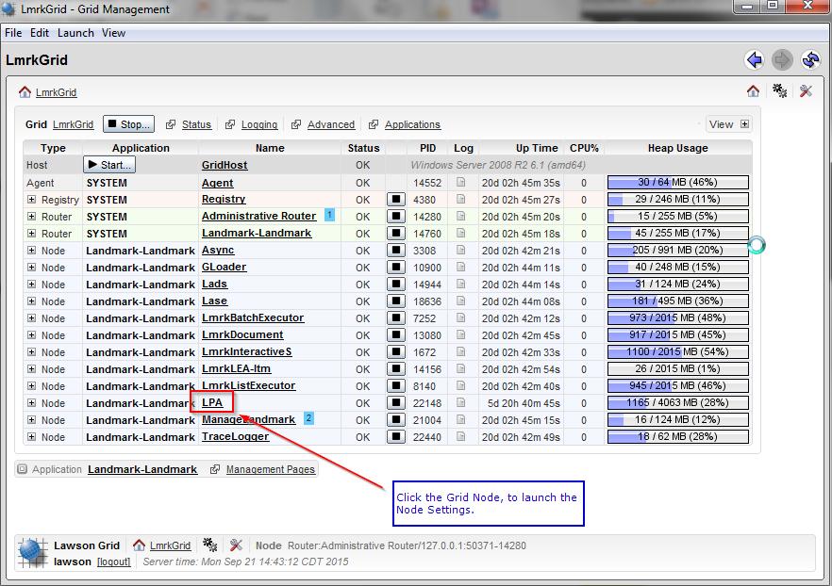

Step 3 – Open the LPA Module
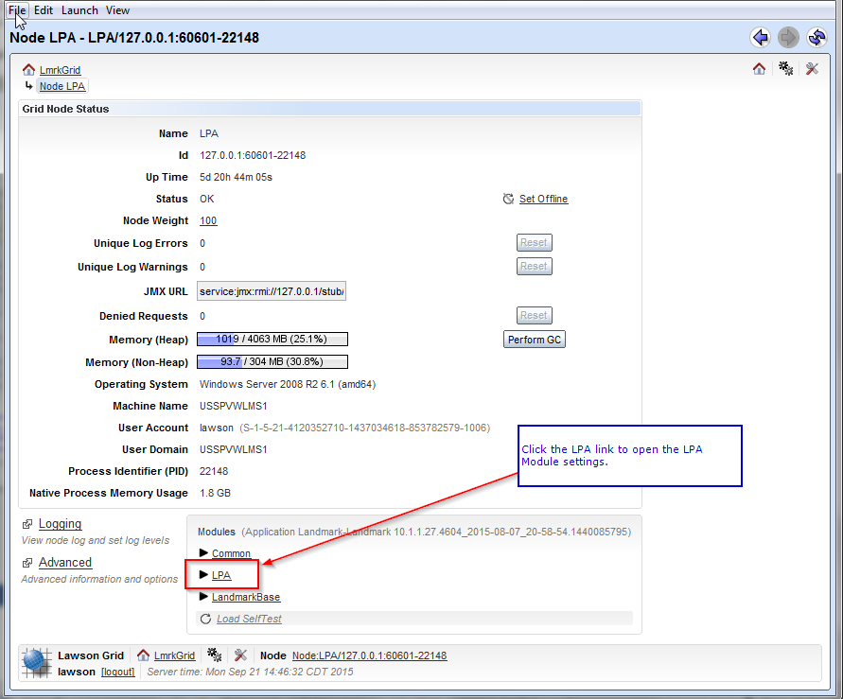
Step 4 – Open the Local Management Pages
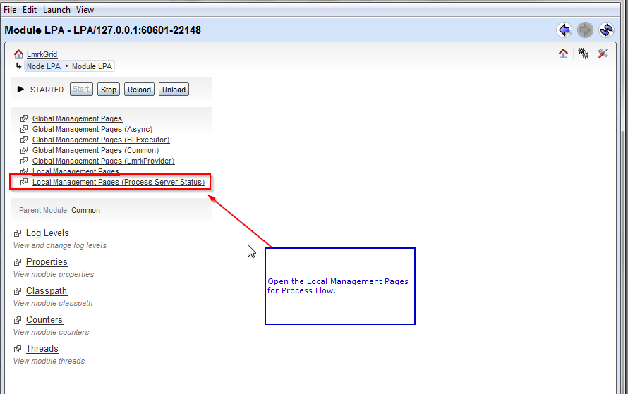

Step 5 – Review this screen for information
